

|  |  |
| --- | --- |
| Product Fields | Details |
| Product Name | apple watch |
| Number of Comments Checked | 1 |
| Overall Product Sentiment | 1 |
| Components Analysed | 1 |
| Prompts Used | 1 |
| Model Accuracy | 1 |
| Date Generated | 2023-04-16 |

## Sentiment Graph Over Time

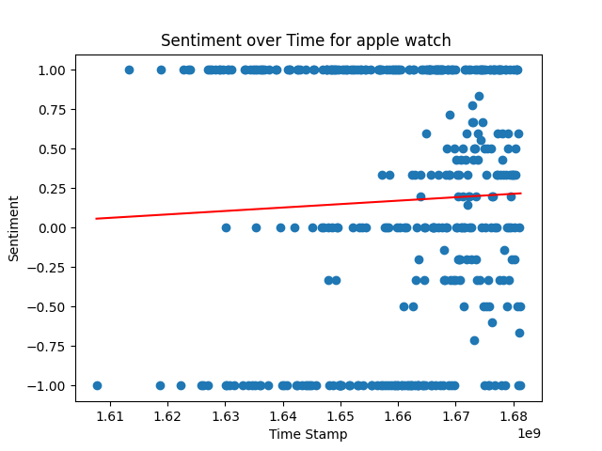

## Table of Recommendations

|  |  |  |  |
| --- | --- | --- | --- |
| Component Specification | Recommendation | Priority | Current Benchmark |
| digital crown design | Recommendation: Increase the size of the speaker and redesign the button for the Action feature to make it more accessible for the user's thumb. | 0 | ergonomic and intuitive |
| heart rate sensor Type | Recommendation: Apple should consider incorporating advanced heart rate and blood oxygen monitoring sensors like those found in the Polar H10 into their future Apple Watch models to provide users with more comprehensive health tracking capabilities. | 0 | Optical sensor |
| accelerometer technology | No Recommendation Given. | 1 | 3-axis accelerometer |
| ambient light sensor type | No Recommendation Given | 1 | photodiode |
| speaker Brand | Reduce the size of the button on the Apple watch to allow for more travel, which will improve the user experience. | 0 | Apple |
| speaker Type | A recommendation to improve the Apple Watch could be to upgrade the mic and speaker for better call quality and add a larger button and digital crown for easier navigation. Additionally, adding language learning apps such as Spanish could enhance the user experience. | 1 | Speaker |
| speaker Connectivity | Recommendation: Enhance the Speaket function on the Apple Watch to provide better call quality and add a video player feature for users to watch videos directly on their watch. | 1 | Bluetooth |
| speaker Size | The Apple Watch should feature larger and more responsive touchscreens to help prevent mis-typing and increase user accuracy when typing or dialing on the watch. Additionally, haptic feedback or audio cues could be implemented to confirm when a user has successfully selected a character. | 0 | Small |
| microphone type | Add a display/nextra button speaker/n to improve the user interface and expand audio capabilities on the Apple Watch. | 0 | digital |
| microphone sensitivity | No Recommendation Given. | 1 | good |
| microphone frequency response | Recommendation: Apple could consider adding an extra microphone and speaker to the Apple Watch to improve the audio quality during phone calls and voice commands. This would make communication easier and more efficient, particularly for those who rely on their Apple Watch as a quick means of communication on-the-go. | 1 | 20Hz-20kHz |
| battery Compatibility | Recommendation: Improve the battery life of the Apple Watch to last at least a week for normal activity or at least 36 hours on extended mode. Additionally, ensure that the waterproof design and industrial design are maintained or improved. It would also be useful if the Apple Watch becomes compatible with regular magsafe to make replacing the battery easier. | 1 | Apple Watch Series 1 - 6 |

## Table of Dall E generated images and associated prompts

|  |  |
| --- | --- |
| Prompts used | Image generated |
| "An Apple Watch user's wrist adorned with a sleek, modern watch that has a display button nestled next to a speaker icon, inviting them to experience an improved user interface." Hyper Realistic |  |
| "A tiny globe spinning on the vibrant touchscreen of an Apple Watch, adorned with colorful flags representing different countries." Hyper Realistic |  |
| "Imagine a giant speaker floating above an Apple Watch, with a redesigned button for activating its Action feature. How would this futuristic accessory look and function?" Hyper Realistic |  |
| "An apple watch with a tiny button, barely the size of a grain of rice, resting on the tip of a finger." Hyper Realistic |  |
| "An Apple Watch user glances at their wrist, mesmerized by the real-time data displayed on their device - heart rate, blood oxygen levels, and more. In the background, a striking image of a beating heart and a swirl of colorful oxygen molecules captures the essence of advanced health monitoring technology." Hyper Realistic |  |
| "A tiny apple orchard grows from the wrist of a giant, yet delicate hand adorned with an intricately designed apple watch." Hyper Realistic |  |
| "A sleek and modern Apple Watch proudly sits on a charging dock next to a brand new microphone and speaker accessory, perfect for taking calls and playing music on-the-go. The vibrant display on the watch face shows a caller ID and music controls, inviting the viewer to imagine the possibilities of this innovative pairing." Hyper Realistic |  |
| "Show a futuristic cityscape with a person talking on their Apple Watch, surrounded by clear and crisp audio waves emanating from the device, highlighting the improved call quality through Enhance the Speaker function." Hyper Realistic |  |
| "Imagine an Apple Watch with an advanced mic and speaker system that lets you take crystal-clear calls and listen to music on-the-go. What would that look like?" Hyper Realistic |  |
| "An Apple watch with a never-ending battery hung on a tree branch, surrounded by lush greenery and chirping birds." Hyper Realistic |  |
| "An apple tree stands tall as its branches weave into a futuristic wristwatch, powered by a system of interconnected energy sources, such as wind turbines and solar panels. A person wearing the watch smiles, knowing they are making sustainable choices with each passing second." Hyper Realistic |  |
| "An apple watch sitting on a desk, with sound waves emanating from its built-in speaker, appearing as if they're blowing away nearby objects." Hyper Realistic |  |
| "An apple orchard spread out over rolling hills, with sleek Apple watches nestled in the center of each juicy red fruit." Hyper Realistic |  |
| "A cartoon apple wearing an Apple Watch, desperately searching for a charging station amidst a sea of dead batteries." Hyper Realistic |  |
| "A person wearing an apple watch with ultra-brightness feature hiking in the mountains at dusk, the watch illuminating their path while the stars twinkle above." Hyper Realistic |  |
| "A miniature apple watch with a holographic display, projecting a vibrant digital world around the wrist. Dall-e captures the futuristic essence, incorporating surreal elements like floating icons and neon hues to inspire creativity and imagination." Hyper Realistic |  |
| "Create an image of a miniature robotic hand holding a green battery that is being inserted into the side of an Apple Watch, as a solution for improving its battery life." Hyper Realistic |  |
| "An Apple Watch with a constantly glowing screen showcases a colorful digital garden, complete with blooming flowers and fluttering butterflies, all magically contained within the confines of the watch face." Hyper Realistic |  |
| "A tiny apple watch powered by a towering battery, nestled in greenery amidst a bustling cityscape." Hyper Realistic |  |
| "Show a futuristic scene where a user is wearing an Apple Watch with a display that shines brightly, powered by renewable energy sources in the background – a world where every tap and swipe is sustainable." Hyper Realistic |  |

Thanks for using the product to generate a report for the apple watch. We hope that the 20 recommendations   
 you have gotten was beneficial for your product developement journey! In general the product has received 1  
 ratings from the youtube and amazon community which are our main source of feedback.